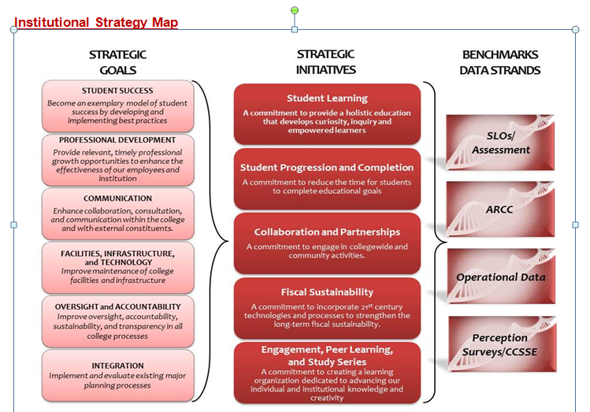
College Council Agenda
March 7, 2014
8:30 a.m. – 10:30 noon
Collins Conference Room

1. | Welcome | All |  | 1 min
2. | Review of Agenda and Minutes** | All |  | 4 min
 | COUNCIL BUSINESS
3. | Accreditation  - ACCJC annual report  - Institutional score card  - Report from ASC retreat on Feb 28th | Christian, Pluta, Gomez-Heitzeberg | Discussion | 45 min
4. | Board Meeting  - March 6, 2014 report to College Council  - April 10, 2014 meeting at BC | Dadabhoy, Christian | Presentation | 10min
5. | Consultation Council Feb 25th agenda | Rodriguez,  Johnson,  Vaughn | Presentation | 10 min
6. | Reorganization Update | Christian | Discussion | 10 min
7. | Baccalaureate Degree | Collier | Discussion | 15 min
8. | Report from Conferences:  - Innovations 2014  - Dream 2014  - 3CBG | Boyles, Tatum  Mourtzanos  Pena | Presentation | 15 min
 | INFORMATION ITEMS: |  |  | 15 min
9. | ASC Report  Program Review Report  Dates to calendar:  March 14th, 8:00 to 12:00. Data Conference: Point of Origin  April 1st, 9:30 to 9:30. Jane Goodall at BC.  April 3rd, all day: Conf on Equity  May 16th: Centennial Graduation |  | Pluta  Christian
 | Next Scheduled Meeting – February 21, 2014
** Supporting documents may be accessed on the College Council Committee website at http://committees.kccd.edu/

