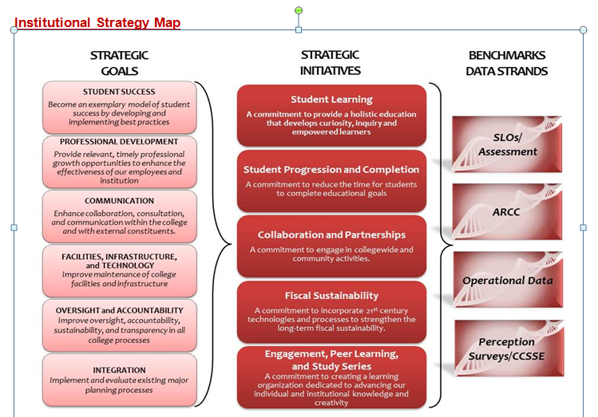
College Council Agenda
February 21, 2014
8:30 a.m. – 10:30 noon
Collins Conference Room

1. | Welcome | All |  | 1 min
2. | Review of Agenda and Minutes** | All |  | 4 min
 | COUNCIL BUSINESS
3. | Accreditation  - Report from the Commission on Feb 7, 2014  - Gearing up for the mid-term report  - Embedding accreditation within the college systems and structures  - Reviewing and revising our mission statement  - Institutional score card | Christian, Pluta, Gomez-Heitzeberg | Discussion | 30 min
4. | Our Dream Act Students | Poetker, Parent | Presentation | 10min
5. | Free Speech | Tatum | Presentation | 10 min
6. | Affordable Care Act Update | Collier | Discussion | 10 min
7. | Student Equity Plan | Arvizu, Goldstein, Hirayama, Coffee | Discussion | 15 min
8. | Institutional Scorecard survey  https://www.surveymonkey.com/s/2XZSVB6 | All |  | 30 min
 | INFORMATION ITEMS: |  |  | 10 min
7. | Items from January 28th consultation council:  - Graduation requirement  - District-wide reserves  - Tobacco Free Campus (Policies 3B1G, 11H1)  ASC Report  Program Review Report  Dates to calendar:  First Generation 90-minute movie showing:  - Feb 18th 5:30-7:00 p.m., FA 30  - Feb 19th, 12:40-2:30 p.m., FA 30  - Feb 19th, 5 – 6:30 pm Delano Auditorium  - Feb 20th, 1:00-2:30 p.m., Forum West  February 21st, 10:30 to 12:00. SSST. Focus on First Generation  March 14th, 8:00 to 12:00. Data Conference: Point of Origin  April 1st, 9:30 to 9:30. Jane Goodall at BC.  April 3rd, all day: Conf on Equity  May 16th: Centennial Graduation |  | Rodriguez,  Johnson,  Vaughn  Pluta
 | Next Scheduled Meeting – February 21, 2014
** Supporting documents may be accessed on the College Council Committee website at http://committees.kccd.edu/

