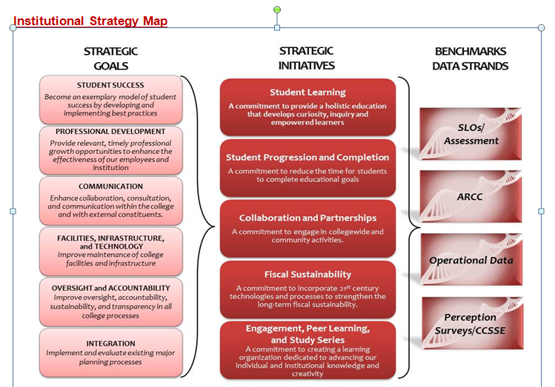
College Council Agenda
October 18, 2013
8:30 a.m. – 10:30 noon
Collins Conference Room

Next scheduled meeting: October 18, 2013
1. | Welcome | All |  | 1 min
2. | Review of Agenda and Minutes** | All |  | 3 min
 | COUNCIL BUSINESS
3. | College-wide Reorganization**  https://committees.kccd.edu/node/683  The task force will present a preliminary outline of their work so far. | Boyles, Marden, Gomez-Heitzeberg | Discussion | 45 min
4. | KCCD Staff Diversity Plan – Diversity & EODAC** (action deferred from 10.4.13 mtg) | Rodriguez, Hirayama | Discussion | 10 min
5. | Decision-Making Documents**  - College DMD Review proposed Committee Charge updates submitted by various committees to update the Decision Making Document (Co-Chairs, ASC, PRC, College Council, Curriculum, Scholarship, ISIT  - KCCD DMD Evaluation | Christian, Pluta, Gomez-Heitzeberg, Strobel, Arvizu  Johnson, Tatum,  Rodriguez,  Vaughn | Discussion  Action | 15 min
 | REPORTS & UPDATES
6. | Reports to College Council  - ASC Report**  - PRC Report | Pluta | Information | 5 min
7. | Consultation Council Items:  - Distance learning - Corny  - Tobacco Free Campus - Travis  - Program Review of Services - Sonya  - KCCD EEOC Plan – Corny & Tina  - Graduation Requirements – Sue & Corny  - Decision-Making Evaluation – Tina & Sue | Johnson  Rodriquez  Vaughn  Christian | Information | 20 min
8. | Accreditation Visit**  - Schedule for October 28th | Christian | Information | 5 min
9. | Review of Calendar**  - Review updated master calendar | Christian | Information | 5 min
Next Scheduled Meeting –
November 1, 2013
** Supporting documents may be accessed on the College Council Committee portal at http://committees.kccd.edu/

