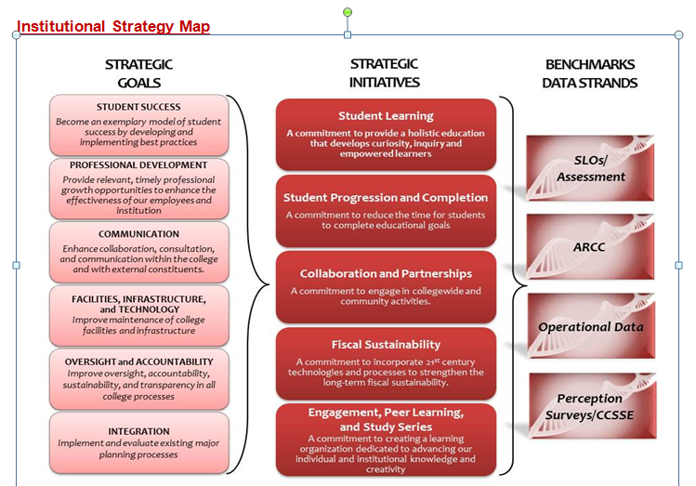
College Council Agenda
October 4, 2013
8:30 a.m. – 10:30 noon
Collins Conference Room

Next scheduled meeting: October 18, 2013
1. | Welcome | All |  | 1 min
2. | Review of Agenda and Minutes** | All |  | 3 min
 | COUNCIL BUSINESS
3. | College-wide Reorganization**  https://committees.kccd.edu/node/683 | Boyles, Marden, Gomez-Heitzeberg | Discussion | 15 min
4. | KCCD Staff Diversity Plan – Diversity & EODAC** | Rodriguez, Hirayama | Discussion | 10 min
5. | Decision-Making Documents**  - College DMD – assign workgroup to review and provide recommendations for updating the document  - KCCD DMD | Christian | Discussion | 10 min
6. | Consultation Council Items:  - Distance learning  - Tobacco Free Campus  - Program Review of Services  - KCCD EEOC Plan | Johnson  Rodriquez  Christian |  | 10 min
7. | Strategic Goal #4: Oversight and Accountability.  A report on the work of the data team | Data Team |  | 15 min
 | INFORMATION ITEMS & REPORTS |  |  | 15 min
8. | Reports to College Council  - ASC Report**  - PRC Report | Pluta | Information
9. | Accreditation Visit**  - Draft schedule for October 28th | Christian | Information
10. | Foundation Board of Directors Retreat Report | Christian | Information
11. | Review of Calendar**  - Review updated master calendar | Christian | Information
Next Scheduled Meeting –
October 18, 2013
** Supporting documents may be accessed on the College Council Committee portal at http://committees.kccd.edu/

